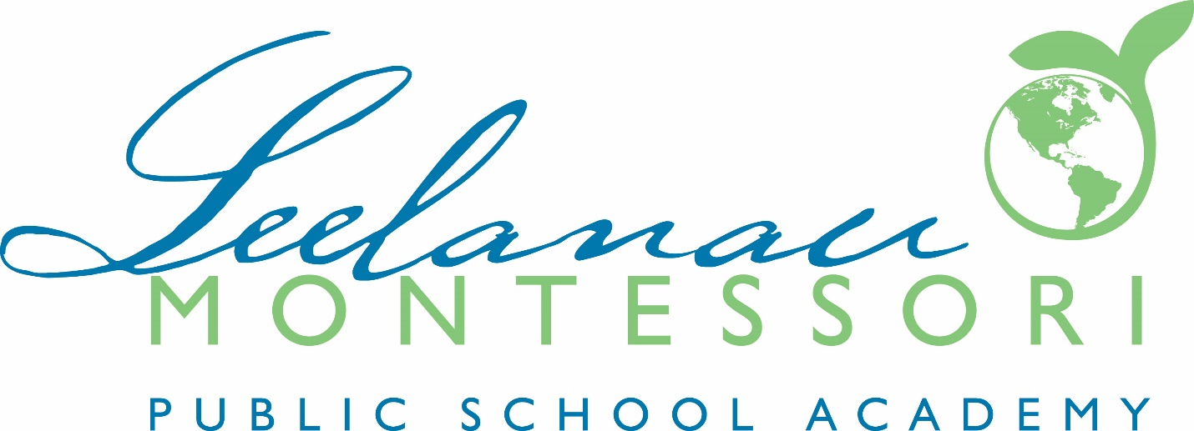
PUBLIC NOTICE:

Leelanau Montessori Public School Academy Board of Directors

The Board of Directors meeting scheduled for
Wednesday, September 20, 2023, 6:00pm
At
8527 E. Government Center Drive
Suttons Bay, MI 49682

Has been
MOVED to

Leelanau Montessori Public School Academy
7401 E Duck Lake Road
Suttons Bay, MI 49653

Official Minutes of the Leelanau Montessori Public School Academy are available at the following location:
www.leelanaumontessori.org

Any person with a disability who needs accommodation to participate in a meeting should contact Nora Goodell at (231)994-2300 at least 7 days in advance of the meeting to request assistance.

